Procedures for the BEREC databases of numbering ranges for value-added services and means of access to emergency services for roaming users

Contents

Executive Summary 2

1. Database of numbering ranges for value-added services for roaming users 2

2. Database of the means of access to emergency services for roaming users 4

3. Communication and dissemination of information 5

3.1. Procedure to populate the databases 5

3.1.1. The procedure for first uploading of the data 5

3.1.2. The procedure for updating the existing information 6

3.1.3. Notification about the update of the databases 6

3.2. Templates 6

Annex 7

Executive Summary

According to Article 16 of Regulation (EU) 2022/612 of the European Parliament and of the Council of 6 April 2022 on roaming on public mobile communications networks within the Union (hereinafter: Roaming Regulation), BEREC is required to establish and maintain a single Union-wide database of numbering ranges for value-added services[1] (hereinafter: VAS) and a database of means of access to emergency services by 31 December 2022. The objective is to protect roaming customers from incurring additional costs when using VAS in visited Member States and to ensure access to emergency services for users while roaming in the EU. Roaming providers are required to use this information in these databases in order to inform their customers about the potential risk of increased charges due to the use of value-added services while roaming and how to access emergency services while roaming. The activity is also included in the BEREC Work Programme 2022 under item 5.2.8 and 5.2.9[2]. In line with the Roaming Regulation and the BEREC Work Program, BEREC developed the databases in the second half of 2022 and established the procedure for filling them in.

These databases may be publicly accessible since the information contained is not confidential, transparency is guaranteed and therefore also end-users shall have the chance to access such information.

National information shall be provided and updated by national regulatory authorities (NRAs) or other competent authorities (OCAs) dedicated contact points in an electronic format, which entails the responsibility for the validation of data input. The BEREC Office will therefore upload information received from NRAs or OCAs to the database without further verification.

In case an NRA is not responsible for collecting relevant information, it shall inform the relevant OCA at national level that the requested data will be provided by the relevant OCA.

# Database of numbering ranges for value-added services for roaming users

As PRN (Premium Rate Number) numbering ranges constitute a subset of value added services (VAS) numbering ranges[3], the currently existing BEREC list of VAS/premium number ranges mentioned above represents the reference starting point for carrying out the work item.

The data fields of the VAS database shall be the following:

| **Field name** | **Field type** | **Length (in Characters)** | **Rules** |
| --- | --- | --- | --- |
| **Country** | Select | - | * Allowing any EU+ country code (i.e. drop down selection) |
| **Country Code** | Number | - | * Allowing only numbers * Numbers must not start with ‘0’ |
| **Code identifying the number range** | Number | - | * Allowing only numbers * Numbers must not start with ‘0’ |
| **Name/Description** | Text | 255 | * Free-text field |
| **Roaming tariff information (optional)** | Text | 1000 | * Free-text field * Allowing special characters |
| **Additional information (optional)** | Text | 1000 | * Free-text field * Allowing special characters |

Figure 1 in Annex shows the work-flow diagram of numbering ranges for value-added services publication. It must be noted that the definition of the VAS numbering ranges category is not harmonised at Union level and the definition of VAS is not included in the new Roaming Regulation; VAS numbers are indeed currently identified in the national Numbering Plans. Therefore, on the basis of the Roaming Regulation the following rules must be followed concerning the numbering ranges to be included in the database:

1. According to Recital (37) and Recital (59) of the Regulation, numbering ranges used for VAS (e.g. premium-rate numbers, freephone numbers or shared cost numbers) are subject to particular pricing conditions at the national level and therefore may generate higher costs also for roaming users.
2. PRN, freephone and shared cost numbering ranges shall be included in the database.
3. EU harmonised numbers[4] shall not be included in the database, unless they generate higher costs for roaming users.
4. The decision of inclusion of national-only numbers[5] is the responsibility of Member States and shall be based on NRA/OCA input.

# Database of the means of access to emergency services for roaming users

Data fields of the database of the means of access to emergency services for roaming users shall be the following:

In case of emergency services:

| **Field name** | **Field type** | **Length (in Characters)** | **Rules** |
| --- | --- | --- | --- |
| **Country** | Select | - | * Allowing any EU+ country code (specific country code list to be provided) |
| **Means of Access** | Select | - | * Allowed values are: * Emergency Calls (Voice) * ‘Emergency Applications’ * ‘Messaging’ * ‘Relay Services’ * ‘Real time text’ * ‘Total Conversation[6]’ * ‘Other’ |
| **Description** | Text | 1000 | * Free-text field |
| **Download Link** | URL link | 1000 | * URL Link field * Allowing special characters |
| **Additional information**[7] | Text | 1000 | * Free-text field * Allowing special characters |

In case of public warning systems:

| **Field name** | **Field type** | **Length (in Characters)** | **Rules** |
| --- | --- | --- | --- |
| **Country** | Select | - | * Allowing any EU+ country code (specific country code list to be provided) |
| **Means of Access** | Text | 1000 | * Free-text field |
| **Type of PWS** | Select | - | * Allowed values are: * App * Cell Broadcast * Location-based SMS * Other |
| **Link to PWS Description** | Text | 1000 | * Free-text field * Allowing special characters |
| **Link to PWS Download** | URL Link | 1000 | * URL Link field * Allowing special characters |
| **Additional information** | Text | 1000 | * Free-text field * Allowing special characters |

Figure 2 in Annex shows the diagram of emergency means and public warning systems publication.

# Communication and dissemination of information

## Procedure to populate the databases

According to Recital 59 of the Roaming Regulation, BEREC should establish the procedures by which competent authorities are to provide and update the information in the database of numbering ranges for value-added services established pursuant to the Roaming Regulation. National data will be collected by the NRAs, and where necessary by the OCAs, and provided to the BEREC Office in order to include them in the databases.

According to Article 16 of the Roaming Regulation for the purposes of the establishment and maintenance of the databases, NRAs and/or OCAs shall provide the necessary information and the relevant updates to BEREC by electronic means without undue delay.

### The procedure for first uploading of the data

1. NRAs were required to fill in the relevant part of the templates – included in Chapter 3.2. – to the relevant database by 24 November 2022.

In case an NRA is not responsible for collecting relevant information, it shall inform the relevant OCA at national level. OCAs were required to fill in the relevant part of the templates – included in Chapter 3.2. – to the relevant database by 24 November 2022. In this case the NRA must have informed the BEREC Office about the contact points from the relevant national OCA in advance of uploading information to the database.

1. The templates can be downloaded from: links to the templates
2. NRAs shall provide data for the BEREC databases of numbering ranges for value added services and means of access to emergency services for roaming users to the BEREC Office email: [pm@berec.europa.eu](mailto:pm@berec.europa.eu).

In case an NRA is not responsible for collecting relevant information, it shall inform the relevant OCA at national level. The OCA shall provide data for the BEREC databases of numbering ranges for value added services and means of access to emergency services for roaming users to the BEREC Office email: [pm@berec.europa.eu](mailto:pm@berec.europa.eu). In this case the NRA must inform the BEREC Office about the contact points from the relevant national OCA in advance of uploading information to the database.

1. BEREC Office shall process the information and upload it in the relevant database.

### The procedure for updating the existing information

1. In case there is a change at national level in the information required by the database, NRAs/OCAs are required to fill in the relevant part of the templates included in Chapter 3.2. – to the relevant database.
2. NRAs and/or /OCAs shall provide the updates for the BEREC databases of numbering ranges for value-added services and means of access to emergency services for roaming users to the BEREC Office email: [pm@berec.europa.eu](mailto:pm@berec.europa.eu).
3. BEREC Office shall process the information and upload it in the relevant database within one working day.

### Notification about the update of the databases

1. As a feature of the database, the interested stakeholders can subscribe to a list, which shall inform the stakeholders about new information in the database[8].

## Templates

The databases can be exported for the purpose of the roaming providers. The upload templates in .xls formats are embedded here:

|  |  |
| --- | --- |
| VAS |  |
| Emergency Means |  |
| PWS |  |

The databases are publicly available here[9].

Annex



Figure 1 BEREC Value- Added Services database

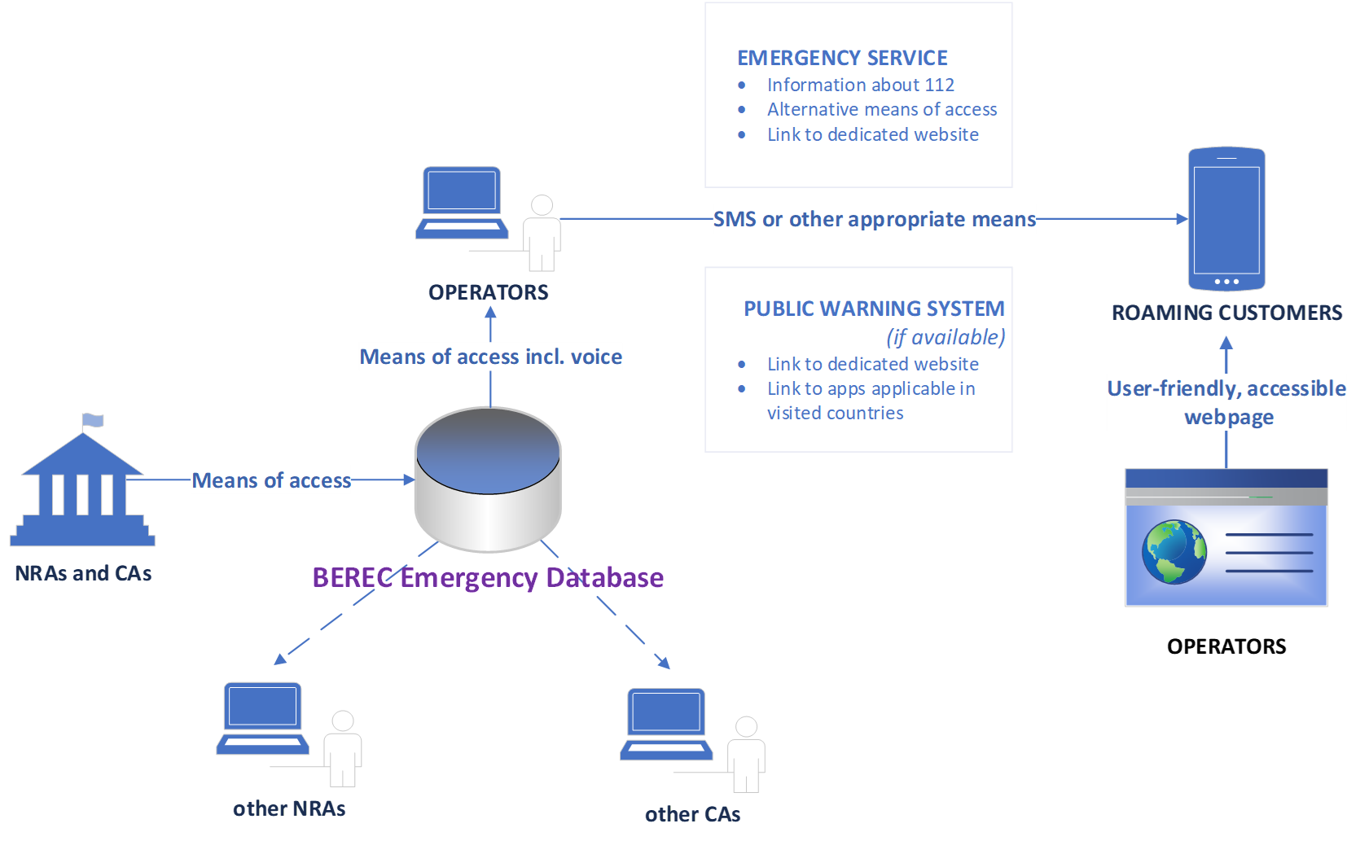

Figure 2 BEREC database for Emergency Means and Public Warning Systems

1. For example communications to premium-rate numbers, freephone numbers or shared cost numbers.
2. BEREC Work Programme 2022, BoR (21) 175.
3. https://berec.europa.eu/eng/about_berec/tasks/premium_number_ranges/
4. For this document EU harmonised numbers: *112* and *116 def* numbers
5. Recommendation ITU-T E.101 – 4.15 (https://www.itu.int/rec/T-REC-E.101-200911-I/en)
6. Total Conversation, as defined in Recommendation ITU-T F.703 [2], is a combination of three media in a

   conversational call: video, Real-Time Text and audio.
7. See Art.16 „…Without prejudice to Article 13, the databases referred to in the first paragraph shall enable national regulatory authorities and other competent authorities, on an optional basis, to provide additional information.”
8. <https://berec.europa.eu/en/vas-numbering-ranges> (VAS); https://berec.europa.eu/en/emergency-means and https://berec.europa.eu/en/pws (Emergency means)
9. <https://berec.europa.eu/en/vas-numbering-ranges> (VAS); https://berec.europa.eu/en/emergency-means and https://berec.europa.eu/en/pws (Emergency means)